Sound System Design

Students Name
Professor
Course
Date

Sound System Design
The sound system is developed using several tools and components. To come up with an adequate sound system, these components and tools should be availed, and a given procedure needs to be followed step by step to come up with the design (Malgieri, 2019). This paper will explain what tools hardware and software preferences required to develop an effective sound system without wasting resources and money. It also aims at creating a purchasing plan
In this case, we shall be installing the sound system for a church to help in the projection of sound during church activities. It shall be required that we consider the church ecosystem before installing the system. More powerful and large speakers will be required owing to the need for a more excellent voice and sound projection in the large building. Besides, there will be more cabling and networking, especially to make it flexible for system users during their respective church activities. Also, it is essential to organize the system in a way that will avoid noise that may be produced by the sound system.
To start with, we need to come up with a reasonable budget that will be able to complete the full installation of the sound system software. We need to have all the components in place. We need a microphone (wired and wireless), a mixer, and a power amplifier. Loudspeakers and all the necessary cabling are also essential in this process. In this case, we will take a wired microphone to make our budget shallower.
Secondly, there's a little need to select a room that will sort the organizations of the speakers' system, and that will provide the optimum conditions for the machines (Belcher, 2019). The photo below clearly shows a well-organized room with the sound system. The room should contain enough space to allow the smart organization of the sound system components. Moreover, the room should have infrastructure that will enable proper projections of sound waves, which will include furniture and other types of hardware.
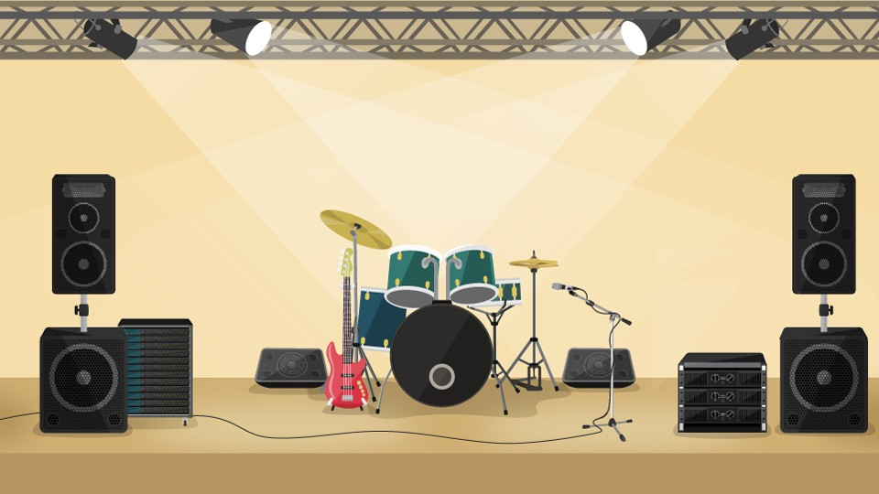
The system will contain non-complex features that will allow the client to have control over the network comfortably. In this case, one of the church members will have control over the system and will be responsible for any technical and non-technical adjustments needed. To save some cash, we will not develop a different electrical structure. The system will contain various portable inputs, including the loudspeaker input as well as the wired microphone's information. This will have the sound system arranged, as shown in the following diagram.
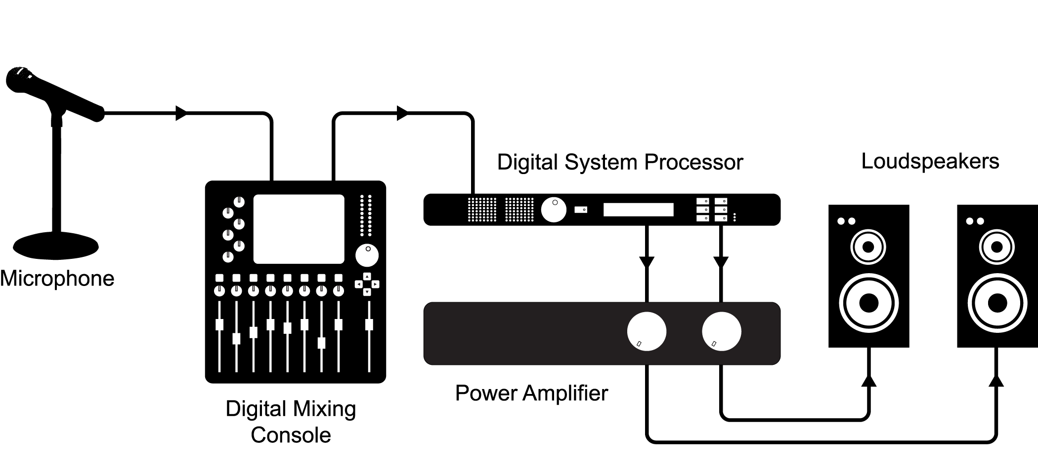
The above diagram makes all the essential sound system components that we installed clear. With the high organization of the components in the proposed room, the sound system will effectively function and generate the desired sounds. Its maintenance measures include a UPS machine that will provide power when there is the unavailability of electricity (Malgieri, 2019). As well, we may use an electric adapter to avoid spoiling of the power amplifier due to electrical shots that may occur.
The process of full installation of the sound system will take approximately two hours to have enough time to polish everything up. This will also count on the messes that may occur during installation, as well as the time it takes to recover them. It is always important to have a well-organized working schedule for events, and this will call for a good and well-organized way of events regarding the installation (Radmanesh et al., 2016). This will be an excellent strategy to attract potential clients. It is always wise for the installer to be the one responsible for purchasing the needed components needed for the full installation.

References
Malgieri, N. (2019). Noise predictions of sound systems using system data and complex summation. The Journal of the Acoustical Society of America, 146(4), 2826-2826.
Radmanesh, N., & Rao, B. D. (2016, March). Frequency-based customization of multizone sound system design. In 2016 IEEE International Conference on Acoustics, Speech and Signal Processing (ICASSP) (pp. 375-379). IEEE.
Belcher, D. (2019, September). Noise Predictions with Sound Systems using System Data & Complex Summation. In INTER-NOISE and NOISE-CON Congress and Conference Proceedings (Vol. 259, No. 1, pp. 8085-8085). Institute of Noise Control Engineering.

